**Question 1:**

Business Rules:

1. Each customer may call any number of other customers.

Additional Business Rules/Assumptions:

1. There can be a customer who does not call anyone.
2. There can be a customer who does not receive a call.
3. CallDuration (HH:-MM) is a derived attribute from CallStartTime and CallEndTime.
4. Call Duration can only be a maximum of 24 hours.

**ER Diagram:** Non-identifying Relationship

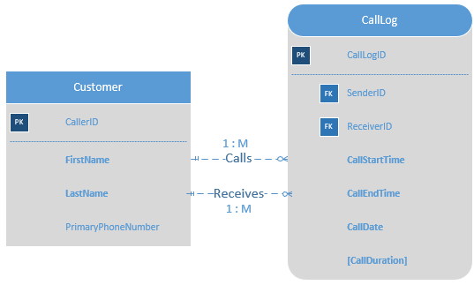

Entities:

1. Customer:
2. Primary Key: **CallerID**
3. Required Attributes: **FirstName**, **LastName**
4. Optional Attributes: PrimaryPhoneNumber

Associative Entity:

1. CallLog:
2. Primary Key: **CallLogID**
3. Foreign Key: SenderID, ReceiverID
4. Required Attributes: **CallStartTime, CallEndTime, CallDate**
5. Derived Attributes: **[CallDuration]**

**Datasheets:**

Customer Table

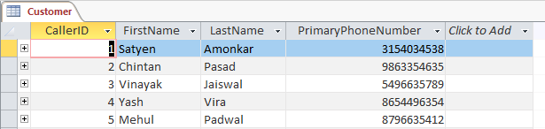

CallLog Table

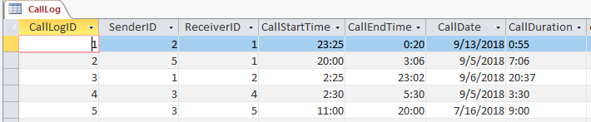

**Data Relationship Model**:

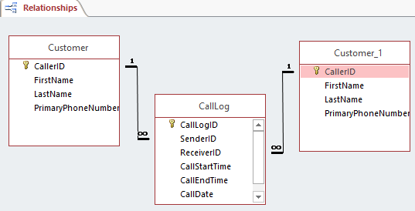

**Question 2**:

Business Rule:

1. Each Student can read many books. Each book can be read by many students.

Additional Business Rules/Assumptions:

1. There can exist a student who does not ready any book.
2. There can exit a book which is not read by any student.
3. Each ReadingRecord must have only one StudentID.
4. Each ReadingRecord must have only one BookID.
5. A student (StudentID) can read a particular book (BookID) only once.

Explanation for using Identifying Relationship:

I have used Identifying Relationship as ReadingRecord should not exist without Student and Book records i.e. A ReadingRecord will exist only if both student and book exist. Also as per the business rule, only one record containing the same StudentID & BookID should exist.

**ER Diagram**: Identifying Relationship

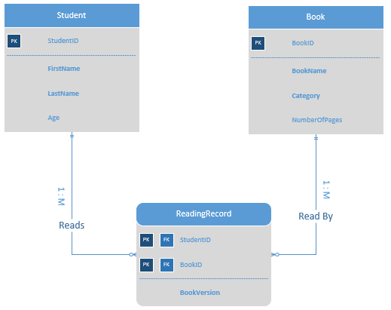

Entities:

1. Student:
2. Primary Key: **StudentID**
3. Required Attributes: **FirstName, LastName**
4. Optional Attributes: Age
5. Book:
6. Primary Key: **BookID**
7. Required Attributes: **BookName, Category**
8. Optional Attributes: NumberOfPages

Associative Entity:

1. ReadingRecord:
2. Composite Key: **StudentID**, **BookID**
3. Foreign Key: StudentID, BookID
4. Required Attributes: BookVersion

**Datasheets:**

Student Table

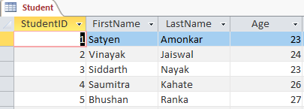

Book Table

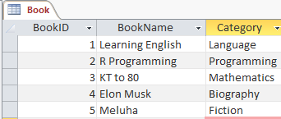

ReadingRecord

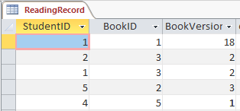

**Data Relationship Model**:

